Tragedy and the Tragic Hero
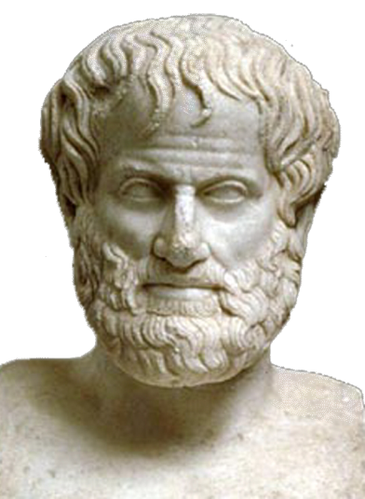
Aristotle (384-322 B.C.) was a Greek who described and reasoned about Greek drama. He laid down lines for future study of drama as a genre, generalizing about the origins, principles and characteristics which he observed in the plays known to him. These plays included the works of Aeschylus, Sophocles and Euripides. He is best known for his Poetics, a masterpiece in literary criticism.

According to Aristotle, a tragedy presents on the stage the actions of “highly renowned” hero with “moral purpose”, who, through some flaw (hamartia), falls into a series of complications. These complications, often caused by “hubris” (excessive pride) involve “events terrible and pitiful”, which in turn tend to arouse the “pity and fear” of those involved (including the audience). The arousing of such emotions, a result of identification with the hero’s plight, so moves all involved that a cleansing of spirit (“catharsis”) is affected.

The tragic hero has to be drawn from the great families, or the gods. Since he is of noble birth, the tragedy is not really confined just to the individual or the family but it affects the entire nation because he is a governor and a representative of the people. He is a talented man, usually famous, but definitely not super-human: he is subject to the entire range of normal human emotions. His downfall is not simply bad luck or an unhappy experience, but neither is it due to and great vices or corrupt morals. What brings about his misfortune is an error in judgement caused by some tragic flaw in his character. Again, this does not mean that he is thoroughly evil; his weakness or flaw simply leads him to make a wrong choice or series of choices, which set in motion an important and causally connected series of events, ending catastrophe. Very often, the flaw is hubris or excessive pride.

