Hamlet Act II Creative Assignment
Materials: You will need a piece of paper and coloured markers or pencil crayons. You may use magazine cut-outs or clip art as well.
Task: Your assignment is to create a visual summary for Act II of Hamlet. To complete this task, you must follow the instructions very carefully:
- Think of an image that represents or symbolizes the whole of Act II and place that image in the centre of your page. Incorporate “Act II” into your image to act as a title for your assignment.
- There are 6 specific categories that need to be attached somehow to your central image. These are: key plot events, setting details, character development, literary devices (imagery, symbolism etc), connection to themes, and significant quotations.
- Label each section clearly and provide details from Act III that suit each category. Provide as much information as possible but keep it summarized.
Also, provide images with the information you place under each section. You could also make some words stand out more than others for emphasis.
Make sure that everything is laid out neatly and logically. It needs to make sense to you but also to ME!
Continue until you have exhausted the content, the space, the time and/or your patience! Remember, you are trying to show me what you know about the significance of Act II.
DUE DATE: _____________________________________
MARKS: 40 (See checklist for grading details).

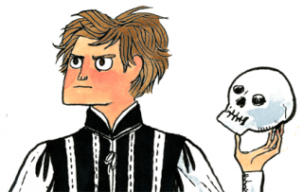

Hamlet Creative Assignment Checklist
Name:
Knowledge and Understanding
- Demonstrates extensive and thorough knowledge of the characters, events, themes, and symbols in the play and understands their significance and meaning.
0 1 2 3 4 5 6 7 8 9 10
Thinking and Inquiry
- Evidence of inferencing and analysis is demonstrated through inclusion of relevant and significant information from Act III supported with ample textual support.
0 1 2 3 4 5 6 7 8 9 10
Communication
- Evidence of critical thinking and creative planning while gathering information and organizing ideas.
0 1 2 3 4 5 6 7 8 9 10
Application
- Careful planning of layout and images show command of design. Creative visual summary is clear and coherent. Significant effort is evident. Proper use of conventions (spelling, grammar, punctuation, citations) is followed.
0 1 2 3 4 5 6 7 8 9 10

Final Mark: /40

